200 câu IOE Lớp 5 VÒNG HUYỆN, CẤP HUYỆN
ĐỀ THI TIẾNG ANH TRÊN INTERNET – OLYMPIC TIẾNG ANH – LỚP 5 - VÒNG HUYỆN

Question 1:
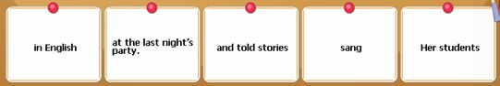
Question 2:

Question 3:

Question 4:

Question 5:
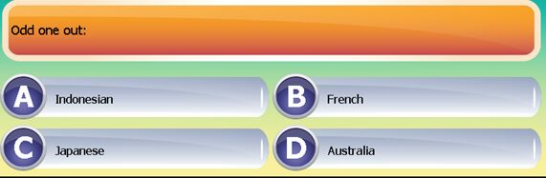
Question 6:
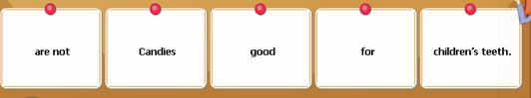
Question 7:

Question 8:

Question 9:

Question 10:

Question 11:
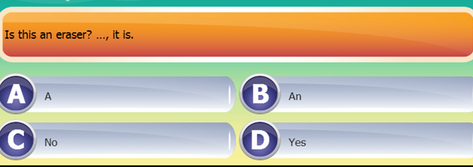
Question 12:
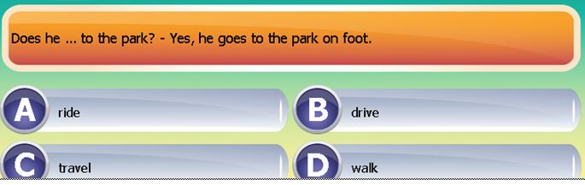
Question 13:
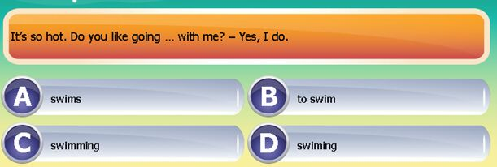
Question 4:
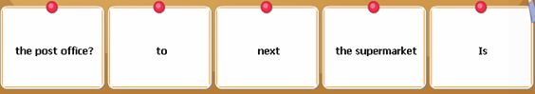
Question 15:

Question 16:

Question 17:
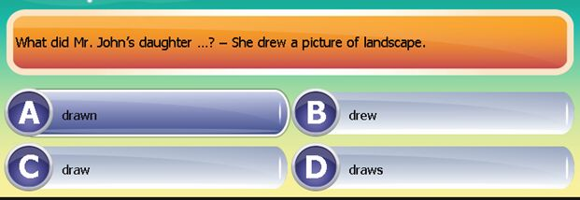
Question 18:

Question 19:
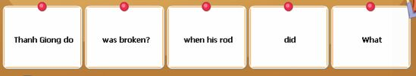
Question 20:
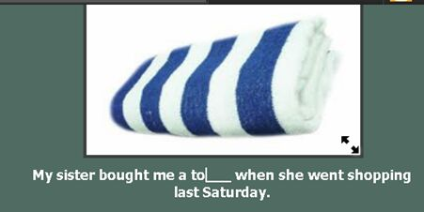
Question 21:

Question 22:

Question 23:
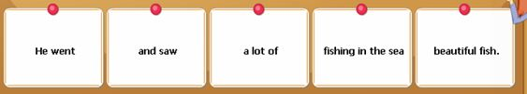

Question 24:

Question 25:
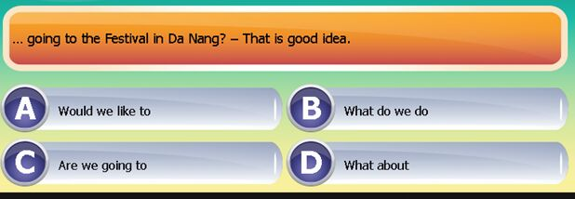
Question 26:
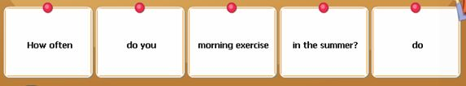
Question 27:
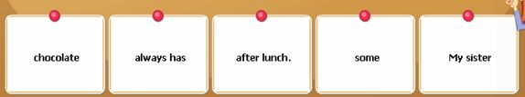
Question 28:

Question 29:
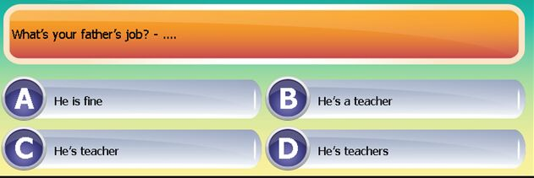
Question 30:
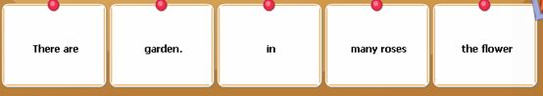
Question 31:
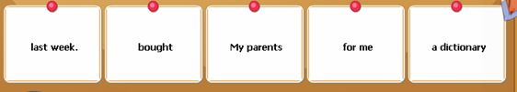
Question 32:

Question 33:

Question 34:
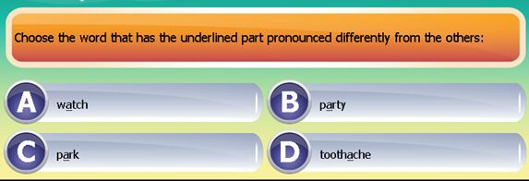
Question 35:
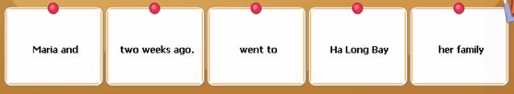
Question 36:
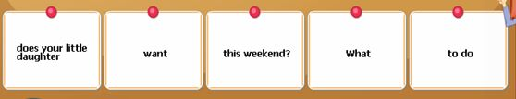
Question 37:

Question 38:
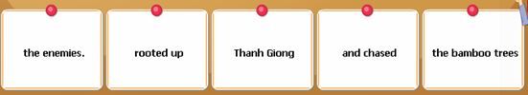
Question 39:
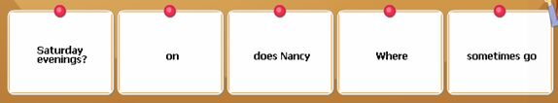
Question 40:

Question 41:

Question 42:
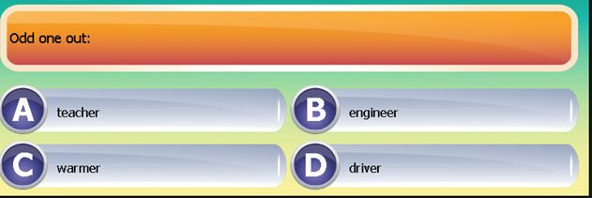
Question 43:
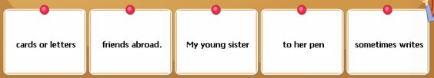
Question 44:
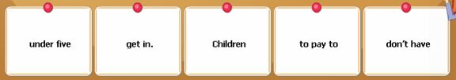
Question 45:
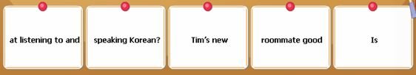
Question 46:
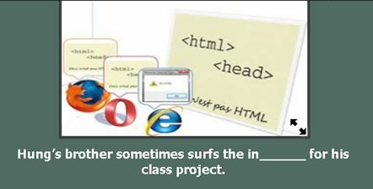
Question 47:

Question 48:
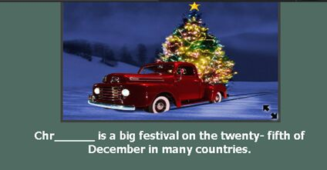
Question 49:
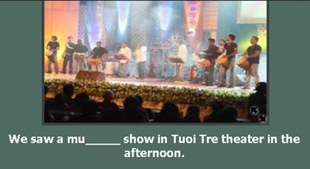
Question 50:
Jim and Sam are _ _ _ _ _ _ _ _ _ _ in Arts. They say it is very interesting.
Question 51:
What _ _ _ _ does your family have breakfast? - At 7 o’clock.
Question 52:
The museum _ _ behind the park.
Question 53:
Look! The boys are talking _ _ _ _ _ the football match.
Question 54:
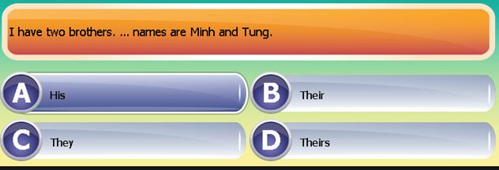
Question 55:
Does Tom p_ _ _ badminton at 4 pm?
Question 56:
The writer of the book you’re reading is _ _ African.
Question 57:
After dinner, my mother checks my homework b_ _ _ _ _ bedtime.
Question 58:
My sister has got some friends from G_ _ _ _ _y.
Question 59:
Fifty- five p_ _ _ twenty-two equals seventy-seven.
Question 60:
What is your k_ _ _ _ _ _ like?
Question 61:
I work _ _ _ _ six o’clock in the morning until three in the afternoon.
Question 62:
.The students played different sports _ _ _ _ as badminton, chess and hide-and-seek.
Question 63:
I am having a birthday party _ _ _ _ my friends.
Question 64:
What is his nationality? – He is A_ _ _ _ _ _ _ _ _(nước Úc).
Question 65:
Where does he live? – He lives _ _ 16 Nguyen Du Street.
Question 66:
My brother is a factory _ _ _ _ _ _. He works in a factory.
Question 67:
There is a small pond b_ _ _ _d the house.
Question 68:
I often write to Jack and tell him _ _ _ _ _ my school.
Question 69:
What d_ _ _ your brother do in the afternoon?
Question 7:
Lena isn’t well today. She is staying at h_ _ _.
Question 71:
What’s the w_ _ _ _ _ _ like in the Summer? - It’s hot.
Question 72:
_ _ _ _ _ does he live? – He lives in Nguyen Du Street.
Question 73:
I live far _ _ _ _ my parents. I phone them everyday.
Question 74:
There is a vi_ _ _ _ fence around my house.
Question 75:
There is a bl_ _ _ fence around my house.
Question 76:
What did your father d_ yesterday evening? - He read newspapers.
Question 77:
I’m not hungry _ _ _ I’m thirsty.
Question 78:
There are many clouds _ _the sky.
Question 79:
Let’s buy a big present _ _ _her birthday party.
Question 80:
_ _ _ _ would you like?-Some soda, please.
81. She/comes/Australia./from
…………………………………………
82. Can you/school/come to/early/tomorrow?
……………………………………………………………………………
83. How many/floors/does/your school/ have?
……………………………………………………………………………
84. She’s/going to/an English song./sing
……………………………………………………………………………
85. She is learning… to use a computer.
A. what B. how C.why D. which
86. Last week, I…to a summer camp in NhaTrang.
A .Did B.was C. went D. were
87. There aren’t any woman…in the room.
A.on B.at C.in D.from
88. Choose the word that has the underlined part pronounced differently
A. late B. place C.take D.dad
89. That/great/idea./a/is
……………………………………………..
90. Her daughter/red shoes/wears/ always /to school.
………………………………………………………………………
91. Friend’s/is/name/Mary./Lan’s
………………………………………………………………………..
92. Mary’s parent/don’t let /night./out at/her go .................................................................................................................
93. to some/tall/is next/The store/trees.
......................................................................................................................
94. ... school are you in?-PhamHongThai school
A.which B. What’s C.When D. Where
95. Choose the word that has the underlined part pronounced differently:
A. grade B. class C. Late D. Name
96. How many...are there in your class ?
A. students B.student C.teacher D .chair
97. Choose the word that has the underlined part pronounced differently:
A. how B. know C. brown D. cow
98. Choose the word that has the underlined part pronounced differently
A.cheap B.meat C.season D.weather
99. Why did’t you... to the cinema yesterday?
A.went B.go C.goes D.going
100. The children/summer camp/wonderful/had a/in Vietnam
........................................................................................................
101. wants/of English./a teacher/ My younger brother/tobe
...........................................................................................................
102. What/going to/you/are/draw,Helen?
.............................................................................................................
103. birthday party./cake and sweets/There are/a lot of/in her
..............................................................................................................
104. Look/at/on/thatman/mortobike.
……………………………………………………………………….
105. your little/son/have English/on Friday/Does/-Yes, he does
……………………………………………………………………………
106. Lan good/Is/at/drawing and singing/yes,she does
…………………………………………………………………………….
107. Odd one out
A. dog B. cow C. pig D. string
108. I like Vietnamese music. - ..........
A. I,too B. So am I C. So do I D. I am, too
109. Choose the word that has the underlined part pronounced differently
A. camp B. table C. travel D. match
110. There is a br_ _ _ fence around my house.
111. _ _ _ _ a lovely song!
112. My brother and I often _ _ _ _ _ TV in the living room
113. Choose the word that has the underlined part pronounced differently
A. paint B. same C. last D. paper
114. We have lots of ...... in the summer.
A. rain B. raining C. rains D. rainy
115. the most helpul/He is/all/of/my assistants
………………………………………………………………
116. they/playing football/interested/in/are.
………………………………………………………………………….
117. why don’t we _ _ to Uncle Tam’s house?
118. how often do you la_ _ for school?
119. how _ _ you spell your name?-L-I-N-D-A
120. How do you feel?-um,I’m…
A.hungry B.doing exercises C.study D.teacher
121. They put a big table …middle in the room.
A.in B.on C.of D.by
122. sister./Lan’s/older/Mai/is
………………………………………………………………………..
123. any/Are there/in your class?/student/German
………………………………………………………………….
124. Hello to/of the world./the chilren/all
…………………………………………………………………………
125. if I were you, I … done that
A.0 b.never c.had’t d.where
126. What is your…of birth-It’s on the eighth of October
A.day B.month C.year D.date
127. Her baby was born ....... 2 o'clock yesterday afternoon.
A. at B. on C. in D. into
128. Which sentence is correct?
A. What's your address? B. Where is your address?
C. Where do you live in? D. In where do you live?
129. …weather is often cool in Sapa.
A. The B. No C. A D. Some
130. Are you free_ _ Sunday morning?
131. _ _ _ _ _ are flowers everywhere in the flat.
132. They’re rich_ _ they don’t have to work.
133. Linda lives _ _ London now.
134. All the children around the world … go to school… six every morning
A.can-from. B.must-at C.can’t-in D.must-from
135. . ......... a letter here ........ you.
A. It's/on B. It's/for C. There's/for D. It has/ on
136. .......... walk on the grass!
A. No B.Not C. Don't D. Doesn't
137. …is behind the house-the flower garden is.
A.where B.who C.what D.how
138. thirty/September/has/days.
.................................................................................................
139. Mum/always/at half past five./gets up
..............................................................................................
140. My mother/some stories./tells me/often
……………………………………………………………………..
141. miss you/so much,/Mom./I
………………………………………………………………………..
142. there’re/months/in the/twelve/year.
……………………………………………………………………………..
143. we say:”twelve”and we write”…”
A.11 B.14 C.15 D.12
144. Let us ..... to the supermarket.
A. go B. going C. to go D. goes
145. Will they go to supermarket tomorrow-yes,they…will.
A. B. tomorrow C.tell D. are
146. What/you/are/doing/now/-they’re/ skipping rose
……………………………………………………………………
147. she’s ill_ _she can’t go to school to day
148. My uncle/vegetable/to the/market/takes/always
…………………………………………………………
149. at twelve o’clock/walks home/his sister/He/and has lunch with
……………………………………………………………………..
150. a quarter/to seven/I/at/go to school
……………………………………………………………….......
151. Lien/hard/worker/is/a
…………………………………………………………………..
152. Mary/noise/always/makes/in the class
…………………………………………………………..
153/ How are you ? – I’m fine, _ _ _ _ _ you.
154/ They are going to stay in Hue _ _ _ a week.
155/ Johnny _ _ from Britain . He speaks English.
156/ What’s the weather _ _ _ _ in the summer ?
157/ What’s the _ _ _ _ _ _ ? I have a fever.
158/ The festival _ _ _ held in the park near uor school.
159/ Sally doesn’t want to eat hamburgers any _ _ _ _ .
160/ _ _ _ _ you at Ha Long Bay last weekend ?
161/ Do you _ _ _ _ many friends ?
162/ I need some stamps. Where is the _ _ _ _ office ?
163/ I can’t go _ _ a trip because we are very busy.
164/ What _ _ _ _ do you get up ? – I get up at 7. am.
165/ Everyday, I clean my room, help my Mom , _ _ _ study English.
166/ My classmates often help each other _ _ _ _ their homework.
167/ My mother is nice _ _ everyone.
168/ _ _ _ _ activities can you do at the festival ?
169/ There are many trees _ _ _ flowers in the park.
170/ Go straight ahead. The park is in f_ _ _ _ of you.
171/ He stays _ _ too late and he is always tired the next morning.
172/ Did Polly enjoy her first day _ _ school ?
173/ _ _ _ do you like informatics. – Because it is interesting.
174/ He plays soccer _ _ _ _ his friends in his free time.
175/ We should go _ _ _ a picnic in autumn because it is very cool.
176/ Why are Science lessons interesting _ _ _ her.
177/ When I _ _ _ a little girl, I liked candies very much.
178/ I’m going to tell you _ _ _ _ _ my new school.
179/ I have a headache. You should _ _ _ _ some aspirins.
180/ _ _ _ - does he do ? He’s a police officer.

