Trường TH Quảng Thành Thứ…….ngày…….tháng……năm 2015

Họ và tên: ………………………… Kiểm tra cuối năm

Lớp: 4A…. Môn Tiếng Anh Thời gian: 40 phút

|  |  |
| --- | --- |
| Điểm | Nhận xét của giáo viên: |

**A. LISTENING (20p**)

**Question 1. Listen and number (1đ) Nghe và điền số**

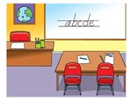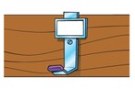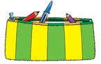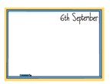

**1**

**Question 2. Listen and write T (True) or F (False) (1đ) (Nghe và viết T hay F)**

* 1. This is the new computer. ...................**T** .
  2. Those are new pegs. ....................
  3. I’m hungry. .................... 4. She can play tennis. ....................

5. She’s got a cheese sandwich ....................

**Question 3. Listen and draw the lines (1đ) Nghe và nối**

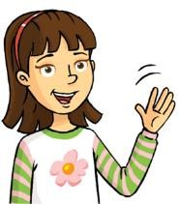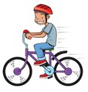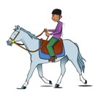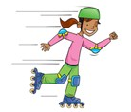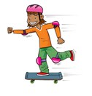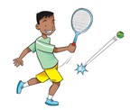

**Question 4. Listen and tick (1đ): Nghe và đánh dấu tick.** Example:

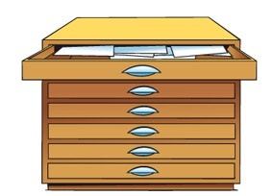 1.

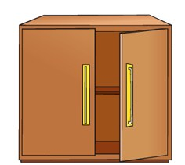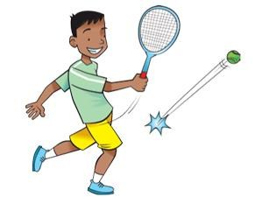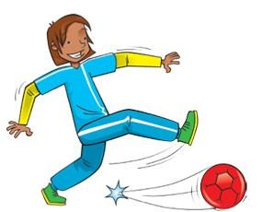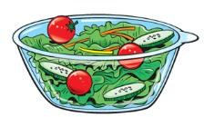

2. 3.

**4. 5.**

**Question 5. Listen and complete (1đ) Nghe và hoàn tất câu**

1. Here is a ……….**tiger.**

It can climb trees.

1. What’s in the …………….? A door and a window.
2. Look ! They’re …………...

Yes, they like apples.

1. I can skate. I can swim.

And I can …………………

1. Have you got …………….? No, I haven’t.

**B/ Reading and writing.**

**Question 6**: Look and read. Put a tick (✓) on the right sentence and a cross (✓) on the wrong sentence (1đ) Example:

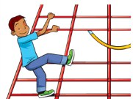 A bird can fly. ✓ He can’t climb ✓

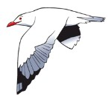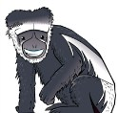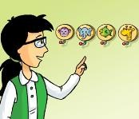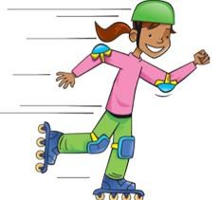

1. A monkey can’t climb. ✓

1. Those are new jugs. ✓

1. They’re thirsty. ✓

1. She can skateboard. ✓

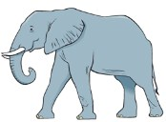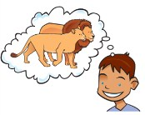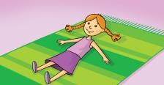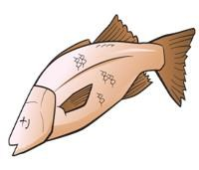

**Question 7**: Look and read. Write Yes or No. (1đ)

Example:

# Yes

An elephant gots four legs.

# No

I like monkeys.

1. There’s a ball on the rug.

1. A fish can’t swim.

1. They’re happy.

1. She hasn’t got a salad.

**Question 8**: Look at the picture. Look at the words. Write the sentences. (1đ)

Example:

|  |  |  |  |  |  |  |  |
| --- | --- | --- | --- | --- | --- | --- | --- |
|  | |  |  |  |  |  |  | | --- | --- | --- | --- | --- | --- | | I’ve | a pen |  | got |  | . | |

I’ve got a pen.

|  |  |  |  |  |  |  |  |  |
| --- | --- | --- | --- | --- | --- | --- | --- | --- |
| fries |  | you |  | Do |  | like |  | ? |



1.

__________________________________

|  |  |  |  |  |
| --- | --- | --- | --- | --- |
| a pillow |  | There’s | the | bed. |

1. on

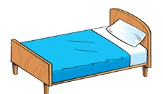

___________________________________

|  |  |  |  |  |  |  |  |
| --- | --- | --- | --- | --- | --- | --- | --- |
| 3  . | |  |  |  |  |  |  | | --- | --- | --- | --- | --- | --- | | talk |  | a | Can |  | monkey | |

?

_________________________________

|  |  |  |  |  |  |  |  |  |
| --- | --- | --- | --- | --- | --- | --- | --- | --- |
|  | |  |  |  |  |  |  |  | | --- | --- | --- | --- | --- | --- | --- | | are |  | hungry |  | They |  | . | |

4.

_________________________________

**Question 9**: Choose the right word/phrases from the box and write them next to numbers from 1-4. (1đ)

|  |  |  |  |  |
| --- | --- | --- | --- | --- |
| Cupboard | Milkshake |  | Scared | Ride a bike |

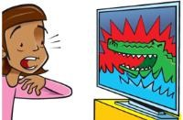 1. _______________ 2. ________________



1. 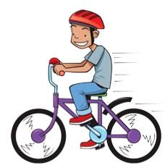_______________ 4. ________________

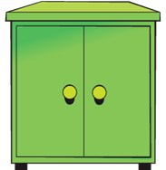

**SPEAKING TEST**

Part 1: Listen and repeat:

**+ Teacher reads or plays the CD, student repeats**

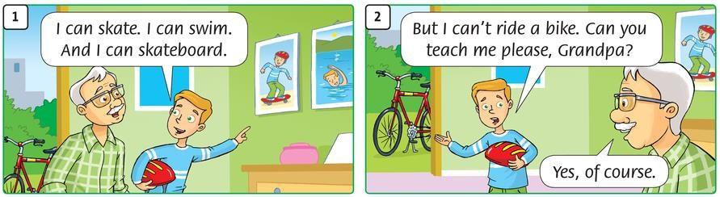

Part 2: Point, ask and answer:

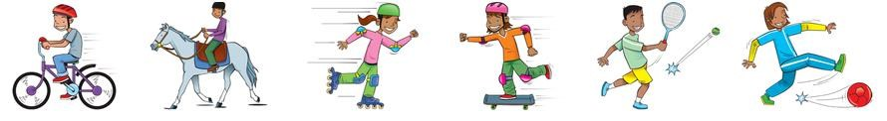

**+ Teacher points and asks, student answers**

Teacher Student

* + **Can she skate? Yes, she can / No, she can’t**
  + **Can he skateboard? Yes, he can / No, he can’t**
  + **Can you ride a bike? Yes, I can / No, I can’t**

…

Part 3: Listen and comment: (Yes or No)

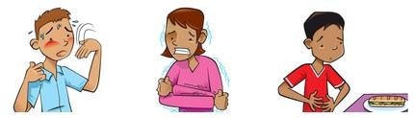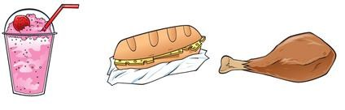

**+ Teacher points and says, student replies**

Teacher Student

* + **He’s hot Yes, he is.**
  + **She’s tired. No, she isn’t.**
  + **This is a sandwich. Yes. It’s a sandwich.** - **Here is a pizza No, it isn’t - It’s a milkshake.**
  + **........**

Part 4: Interview:

**+ Teacher asks pupils to work in pairs.**

**+ Pupils ask and answer with the questions below:**

* + **What’s your name? Can you ride a bike?**
  + **How old are you? Are you hungry?**
  + **How are you? ……..**
  + **What’s this?**
  + **Do you like....?**
  + **What do you like?**
  + **What’s your favorite colour?**
  + **What’s your favorite toy?**

**ANSWER KEY A. LISTENING.**

|  |  |  |
| --- | --- | --- |
| **Question 1.** 1. classroom 2. board  4. computer 5. pencil case | 3. peg |  |
| **Question 2.** 1. T 2. T 3. F    **Question 3.**  Rosy - Tim  Ride a bike - skate Ride a horse - play tennis  skateboard    **Question 4.** | 4. T 5. F |  |
| 1. cupboard 2. hot 3. play football    **Question 5.** | 4. fries | 5. forty |
| 1. tiger 2. classroom 3. hungry    **B**: **READING AND WRITING.** | 4. skateboard | 5. a sandwich |
| Question 6: 1. ✓ 2. ✓ | 3. ✓ | 4. ✓ |
| Question 7: 1. No 2. No | 3. Yes | 4. No |
| Question 8: 1. Do you like fries? | 2. There’s a pillow on the bed. | |
| 3. Can a monkey talk? | 4. They are hungry. | |
| Question 9: 1. Milkshake 2. Scared | 3. Cupboard 4. Ride a bike | |